SECTION A (60 Marks)
Answer only three questions from this section.
- State Hess’s law of constant heat summation. (01 mark)

- .Explain what is meant by each of the following terms and in each case write an equation to illustrate your answer. (@02 marks)
- Lattice energy.
- Hydration energy.
- Explain two factors that affect the value of lattice energy of a compound. (03 marks)
- In an experiment to determine lattice energy of anhydrous copper (II) sulphate, 4.0g of anhydrous copper (II) sulphate was added to 50.0g of water and the temperature rose by 8.0ᵒC.When 4.0g of anhydrous copper (II) sulphate was added to 50.0g of water and the temperature dropped from 24.5ᵒC to 23.6ᵒC.[S.H.C of solution = 4.2J/g/K]
Calculate the enthalpy of solution of: (@03 marks)
- Anhydrous copper (II) sulphate.
- Copper (II) sulphate-5-water.
- State which one of the two copper (II) salts in (d) is more soluble in water and explain your answer. (03 marks)
- Using a Born-Haber cycle determine the hydration energy of anhydrous copper (II) sulphate. (03 marks)

- Both phenol and ethanol contain the same functional group.
- (i) Name one reagent that can be used to distinguish between the two compounds. (01 mark)
- State what would be observed if each of the compounds is treated with the reagent you have named and write the equation for the reaction that occurs if any. (03 marks)
- Describe three ways in which the chemistry of phenol is similar to that of ethanol. (03 marks)
- Mention two use of phenol. (02 marks)
- An aqueous solution of phenol turns moist blue litmus paper red where as that of ethanol has no effect. Explain this observation. (04½ marks)
- Write the equation and mechanism for the reaction between.
- Phenol and 2-chloropropane in alkaline conditions. (02 marks)
- Ethanol and methanoic acid in presence of sulphuric acid. (04½ marks)

- (a).Write the general outermost electron configuration of group (IV) elements. (0½ mark)
- Describe the reactions of:
- Carbon, Silicon, Tin & Lead with water. (06½ marks)
- Lead with ethanoic acid. (02 marks)
- Chlorides of lead with dilute sodium hydroxide solution. (04 marks)
- Lead (IV) oxide with concentrated hydrochloric acid. (05 marks)
- Silicon with acids. (02 marks)

- Explain the following observations:
- When propanone was mixed with trichloromethane, A warm miscible mixture was formed whose volume was lower than the sum of the volumes of the individual components. (04 marks)
- Methanoic acid forms a silver mirror with Tollen’s reagent while ethanoic acid gives no observable change. (04½ marks)
- Hydrofluoric acid is a weak acid but its strength increase in concentration. (05 marks)
- Phenylamine is a weaker base than ethylamine. (04 marks)
- A mixture of benzene (boiling point 80ᵒC) and water (boiling point 100ᵒC boils at a temperature. (03 marks)

SECTION B (40 Marks)
Answer only two questions from this section.

- Write equations to show how each of the following compounds can be synthesized. In each case, indicate a mechanism for the reaction.

- Zinc is a d-block element but not a typical transition metal element. Briefly explain the following terms: (@01 mark)
- d-block elements.
- Transition element.
- Explain why zinc is not considered as atypical transition element. (01½ marks)
- Describe three ways in which the chemistry of zinc is similar to that of magnesium. (07½ marks)
- State what would be observed and write the equation (s) for the reaction that occurs when dilute aqueous ammonia is added drop wise until in excess to an aqueous solution of zinc sulphate. (03 marks)
- 3.0g of zinc ore was dissolved in excess concentrated ammonia and the solution was made up to 500cm³ with water. The resultant solution was shaken with carbon tetrachloride and left to stand.25cm³ of the organic layer required 12.50cm³ of 0.025M hydrochloric acid for complete neutralization. 12.50cm³ of the aqueous layer was neutralized by 20.0cm³ of 0.25M hydrochloric acid. [K_{D} of ammonia between carbon tetrachloride & water = 0.04]
- Calculate the percentage of zinc in the ore. (05 marks)
- State any other two application of partition coefficient. (02 marks)
- Soap can be prepared from fats and oils.
- (i) State one differences between fats and oils. (01 mark)
(ii)Name two sources of vegetable oil. (02 marks)
- (i) What is the chemical nature of all soaps? (01 mark)
(ii)Give a chemical name of an example of soap. (01 mark)
- Soap was prepared from 9.5g of oil containing mainly Hexadecanoic acid [CH₃(CH₂)₁₄COOH] as the main component of the oil.
- Explain briefly how pure soap was obtained from oil.(04 marks)
- Calculate the mass of the soap formed. (03 marks)
- Name two uses of the residue left after the oil has been extracted. (01 mark)
- Explain clearly how soap or detergents remove grease particle during washing process. (03 marks)
- Explain the difference between soap and detergents. (02 marks)
- Give one advantage and demerit of using detergents. (02 marks)

- The standard potential for some half-cells are shown below:
Fe³⁺_{(aq)}/Fe²⁺_{(aq)} ⁺0.76V I_{2(aq)}/I⁻_{(aq)} ⁺0.54V
- What is meant by the term standard electrode potential? (01 mark)
- Using a well labelled diagram, describe how the standard electrode potential of iron (III) sulphate can be determined. (06 marks)
- Why is it not possible to measure the standard electrode potential of iron (III) sulphate absolutely? (02 marks)
- Write the cell convention and the equation for the overall reaction that occurs when the electrode potentials in (a) above are combined. (02½ marks)
- Calculate the overall electrode potential for the cell. (01½ marks)
- State whether the reaction in (c) above is feasible or not. Give a reason for you answer. (01 mark)
- A current of 40.5A was passed through molten lead (II) bromide for 4 hours and the bromine liberated reacted with 94.0g of hydroxyl benzene. Calculate the moles of: (@02 marks)
- Bromine liberated.
- Hydroxybenzene that reacted.
- State what is observed and write the equation for the reaction that took place between bromine and hydroxybenzene in (e) above. (02 marks)

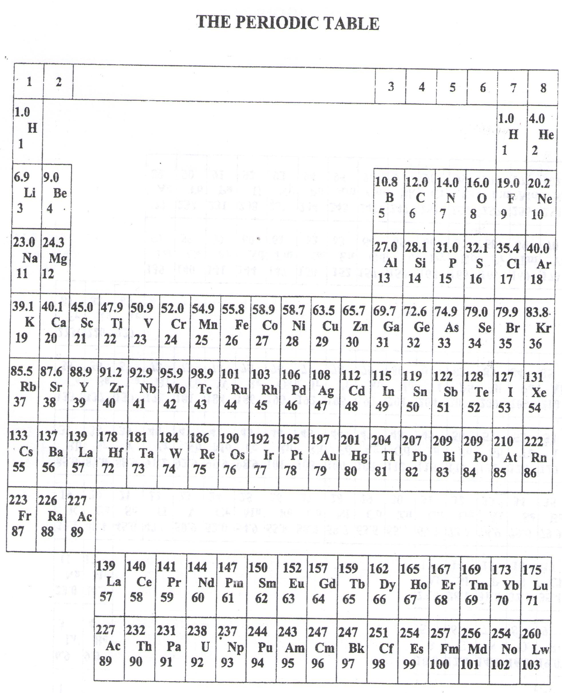

- ===END===
WELCOME TO SENIOR SIX, YEAR 2023
This is the last page of the printed paper, Page 06

